Trigger | Description
Reproductive Optimization | Swarming is triggered when the workers can support more eggs than the queen can lay. A leveling off of brood related tasks.
Colony Size | The active worker population reaches a particular size and/or density threshold during a time of accelerated population growth, and this triggers queen rearing.
Worker Age Distribution | At the beginning of the growing season, the age distribution of a colony is greatly skewed towards older (≥ 24 days old) workers. Gradually, as the older workers die and increasing numbers of eggs are laid, develop into adults, and eclose (give rise to) to take their place, the proportion of younger (≤ 7 days old) workers increases. Once this proportion of younger workers reaches a particular threshold this triggers queen rearing.
Brood Comb Congestion | As the queen continues to lay an increasing number of eggs over time, the number of empty cells in the brood comb decreases. The greater numbers of eggs necessitate an increase in the number of adult workers caring for the brood. This increased density of adults on the brood comb, coupled with the decreased density of empty cells into which the queen can lay her eggs, triggers queen rearing.
Reduced Transmission of Queen Pheromones | Queen honey bees produce pheromones that have been shown to inhibit queen rearing in workers (Winston et al., 1990). These pheromones are transmitted both directly from queen to worker and between workers via ‘messenger bees’ (Seeley, 1979). As the colony grows in size and becomes increasingly congested, the queen and her messengers either come into direct contact with each worker less frequently, or else maintain their contact rate with a progressively smaller proportion of the worker population, thereby weakening the effective ‘dose’ of pheromone each is able to deliver. This reduced dispersal of the queen’s pheromones triggers queen rearing.
Swarming Triggers
Interdependent consequences of a hive nearing ‘replacement stability’, i.e., colony can no longer increase. The triggers may be simultaneous artifacts (correlates) of the actual mechanistic cause of swarming.

[Research article - A modeling approach to swarming in honey bees (Apis mellifera)]

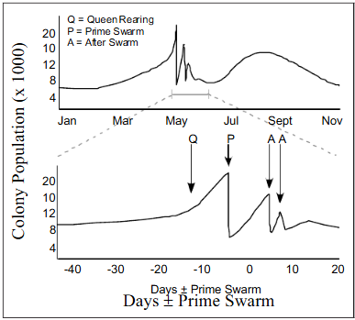
Time speciﬁc colony size and swarming patterns. In the month represented in the graph by days –40 to –10, the colony grows by ~3,000 bees. In the days represented by days –10 to day 0, the colony grows by ~10,000 bees. Since the average life expectancy of a worker over the growing season is 31 days (17days in a resent study), over the course of a month, all of the workers must be replaced. In order for a colony to grow by 3,000 bees (from 9,000 to 12,000), the queen must have laid (starting 21 days in advance) 9,000 eggs to replace the original population and 3,000 additional eggs in order to increase the colony size. As such, the queen must have laid 12,000 eggs in the course of 31 days. This indicates that her laying rate is approximately 400 eggs per day. Similarly, in order for the colony to grow from 12,000 to 22,000 bees over a period of 10 days, she must have laid as many eggs as would replace approximately 1/3 of the original 12,000 bees, in addition to the 10,000 necessary to increase the colony size. This indicates that the queen is laying approximately 1,400 eggs per day during this period. These numbers imply a sharp increase in egg laying rate at a particular point in the growing season.
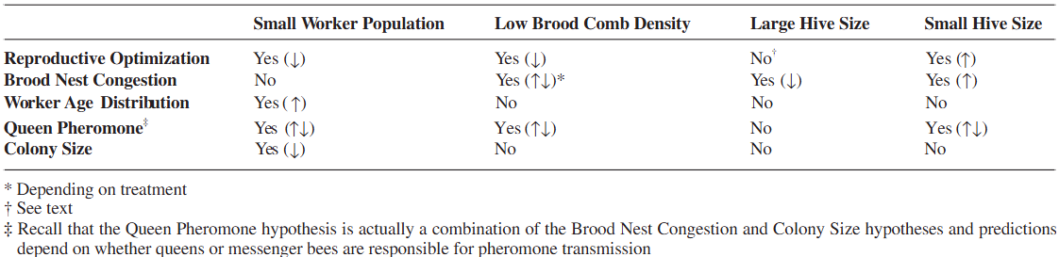
Expected results of different trigger mechanism hypotheses on the various experimental swarm-preventing manipulations. The assumed starting condition for the hive is that swarming is imminent, just prior to the production of queen cells (e.g., the queen has reached maximal egg laying rate, the colony has reached a certain number of workers, etc.). Swarm-preventing manipulations include: Small worker population (the removal of workers), low brood comb density (the removal of brood comb), and large & small hive sizes (an increase or decrease in physical hive size, respectively). Yes: manipulation is expected to affect swarming; No: manipulation is not predicted to affect swarming; Arrows indicate increase or decrease in swarming.

